# **Restriction on Chart of Accounts**

**Introduction:**

* We have implemented a new security feature to restrict modifications to the Chart of Accounts.

**New Functionality Overview:**

* Users who have the access of **“Allowed create chart of accounts”** will be able to create, update, and delete records in the Chart of Accounts.

**How to give access of chart of accounts to user:**

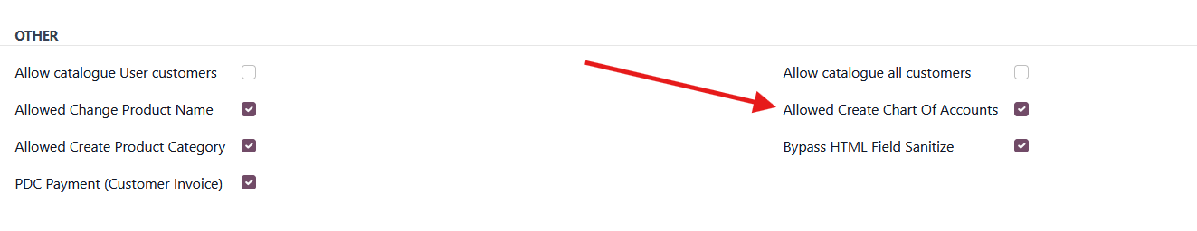

**Allowed Create Chart Of Accounts : User Profile**

# 

# 

# 

# 

# 

# 

# **Catalogue Distribution**

**Introduction:**

* The Catalogue Distribution is designed for distributing catalogues to salespersons and customers.

**Pre-requisites Before Creating a Catalogue:**

Before generating a catalogue, certain conditions must be met:

* Category Setup: Define product categories to classify products systematically.
* Catalogue Creation: A catalogue is created based on product categories.
* Product Availability: Products must be available in stock before they can be added to a catalogue.
* Stock Management: Products should be purchased and added to inventory before they are available for sales.

**Why Create a Catalogue?**

Creating a catalogue provides the following benefits:

* Easy Product Comparison: Enables users to compare multiple products efficiently.
* Detailed Product Information: Gives an opportunity to showcase product specifications, features, and benefits.
* Improved Sales Process: Helps salespersons present products systematically to customers.
* Better Inventory Management: Ensures that only available products are included in the catalogue.

**Catalogue Distribution Scenarios**

The catalogue is distributed based on predefined rules and access levels:

* User → Salesperson
* User → All Customers
* User → Particular Salesperson Customers

**Note:**

* A user's location is required for distributing a catalogue. If a location is not set, it will be impossible to share the catalogue from one location to another.

**Why is Location Required for Catalogue Distribution?**

* Location is necessary to manage catalogue distribution efficiently and ensure users receive relevant product information based on their area.
* A catalogue is shared from one location to another; without location data, it would be impossible to determine which users should receive a particular catalogue.
* Location-based distribution prevents unnecessary access and ensures that users only receive catalogues relevant to their assigned region.
* It also helps in managing inventory effectively by distributing catalogues based on available stock in different locations.

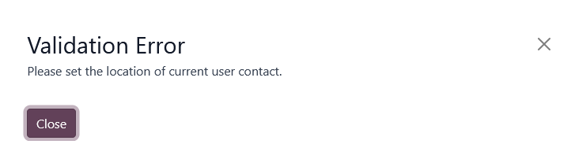

* Catalogue transfers occur between locations. If a user has no assigned location, an error will be shown to prevent catalogue distribution.

**Managing Customer Access in Catalogue Distribution**

* The system allows the user to configure customer visibility settings.
* If access to this permission, a salesperson can see and distribute catalogues to **all customers**.

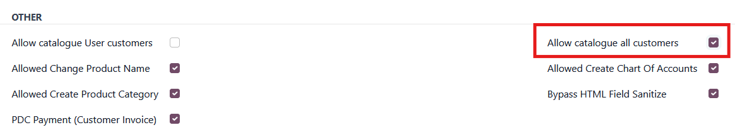

**Allow catalogue all customers : User Profile**

* If access to this permission, a salesperson can only see and distribute catalogues to their **assigned customers**.

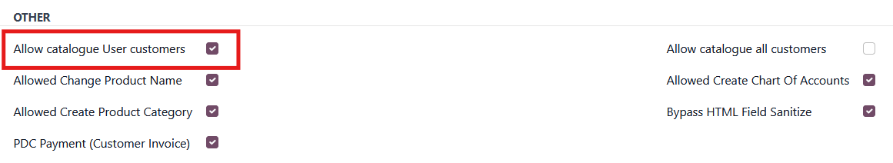

**Allow catalogue assigned customers : User Profile**

* This ensures controlled access and prevents unauthorized users from viewing catalogues meant for specific customers.

## 

## **User → Salesperson**

* A User without a location set will not appear in the Salesperson List.

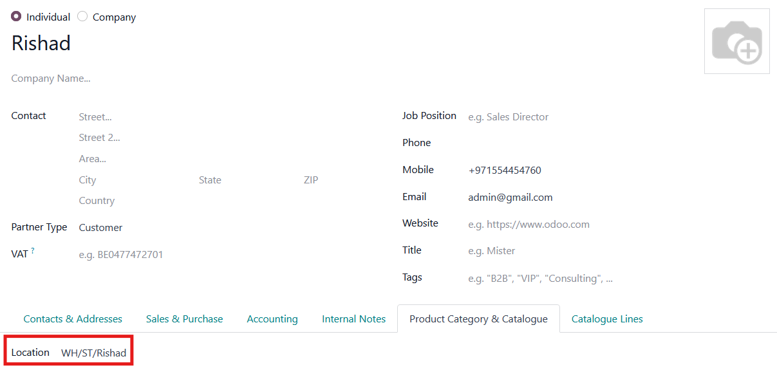

**Location assigned**

* Once a location is set, the salesperson will appear in the Salesperson List.
* You can now distribute catalogues to a salesperson.

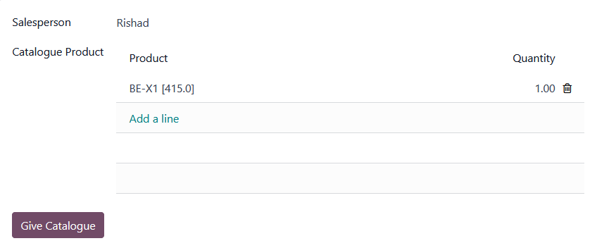

**Salesperson Catalogue Distribution**

## 

## **User → All Customers**

* If a user has no assigned location, an error will be displayed to “Please set the location of current user contact”.
* If a user's customer permission is “Allow catalogue all customers” , a salesperson can view and distribute catalogues to **all customers.**
* You can now distribute a catalogue to all customers.

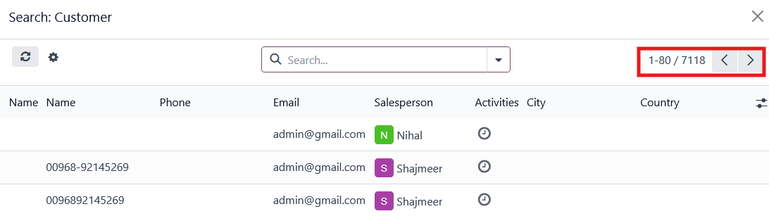

**Customers List**

## **User → Particular Salesperson Customers**

* If a user has no assigned location, an error will be displayed to “Please set the location of current user contact”.
* If a user's customer permission is “Allow catalogue User customers”, a user can only access and distribute catalogues to their own customers.
* You can now distribute a catalogue to current user customers.

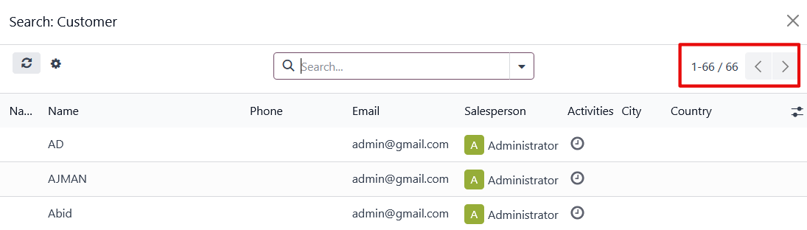

**Customers List**

# 

# 

# **Catalogue Management**

**Introduction**

* The Catalogue Management is designed to track distributed catalogue records.
* When a catalogue is distributed, a record is created in the Catalogue Management.
* When a product is sold through an assigned catalogue, the existing record is updated in the Catalogue Management.
* The record links the customer, sold product, and user who assigned the catalogue.

**Note:**

* If a catalogue is not distributed to a customer and the user sold a product to that customer, no record will be generated in the Customer Catalogue Management at that time.

**Example Scenario:**

**Customer Catalogue Management**

* A user assigns a catalogue to a customer.

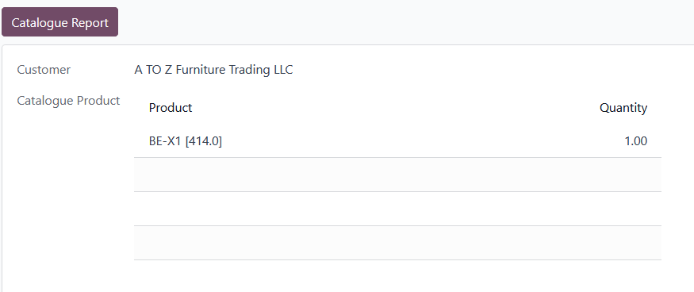

* The sold product from the catalogue.

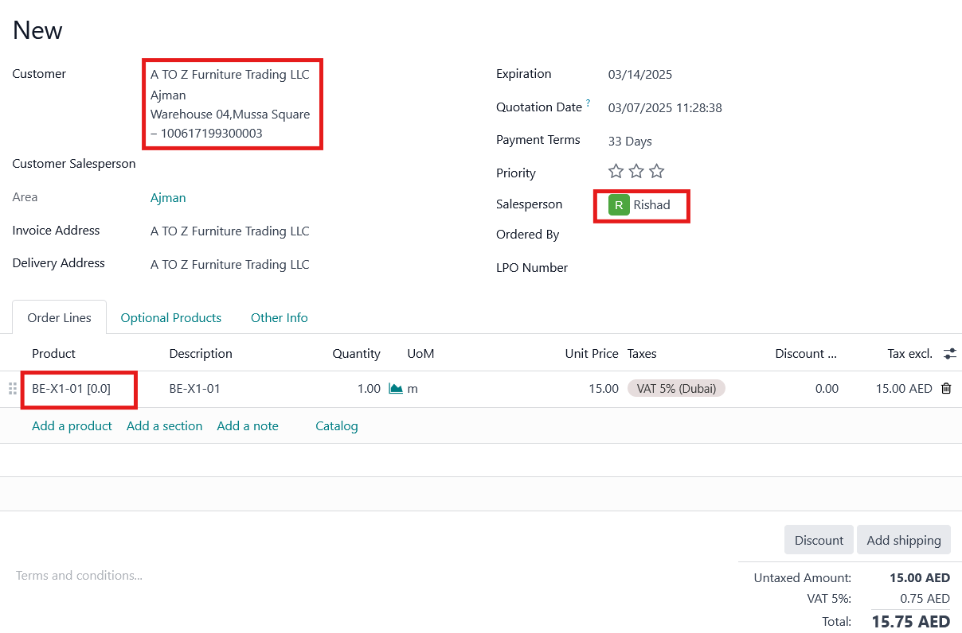

* The records are generated in “Customer Catalogue Management”, linking the customer and the user who assigned the catalogue.
* When the Sale Order is “confirmed”, the “Sale Orders Quantity” and “Untaxed Amount” will be updated in Customer Catalogue Management.

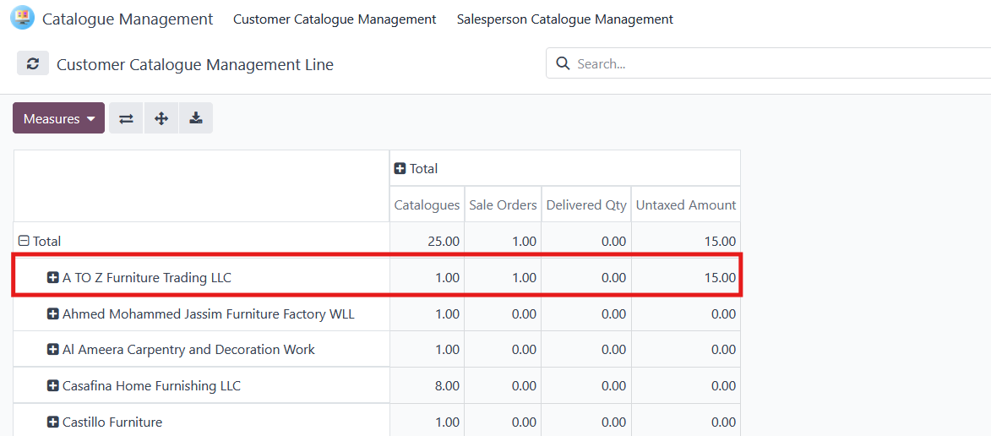

* When the Delivery Order is “validated”, the “Delivered Qty” and “Invoiced Qty” will be updated in Customer Catalogue Management.

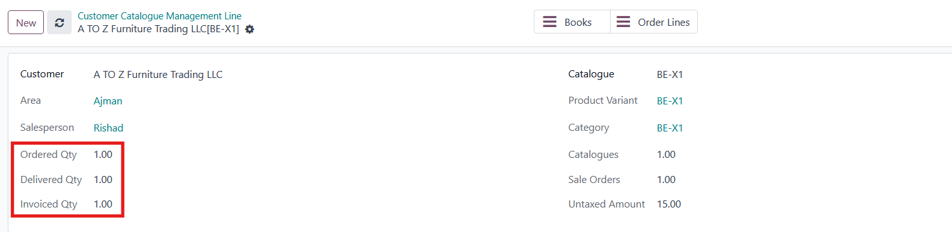**Customer Catalogue Management**

* Ordered Qty: This field shows the quantity that was ordered at the time of order creation.
* Delivered Qty: This field shows the quantity that has been delivered.
* Invoiced Qty: This field shows the quantity for which an invoice has been created.
* When you click the **"Books"** button, it will display the book details, including the number of books given to the customer.

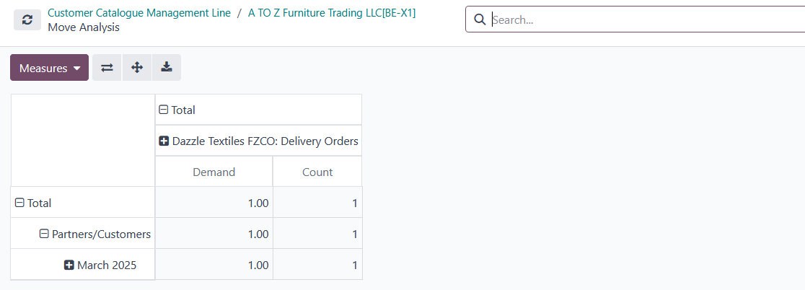

**Customer Catalogue Management Books**

* When you click the **"Order Line"** button, it will display the order line details.
* The order lines are shown in this button when a sales order is created.

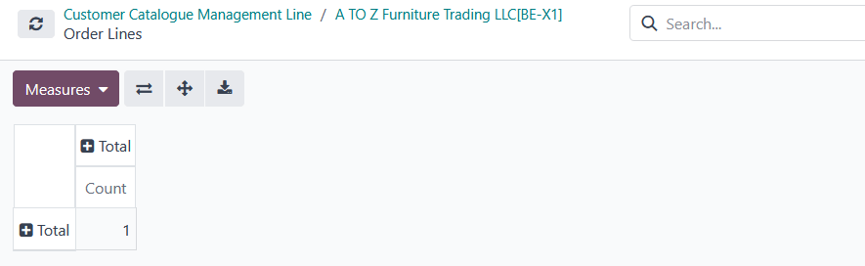

**Customer Catalogue Management Order Liens**

**Salesperson Catalogue Management**

* A user assigns a catalogue to a salesperson.

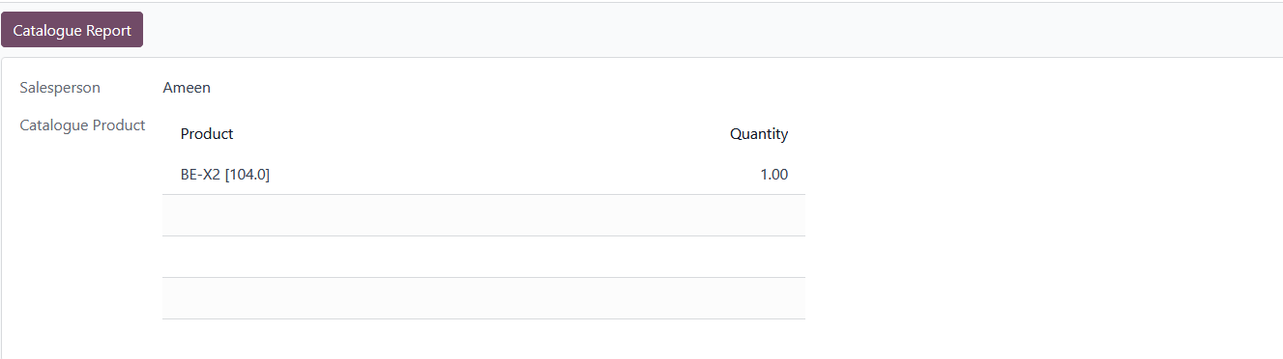

* The records are generated in “Salesperson Catalogue Management”, linking the salesperson and the user who assigned the catalogue.

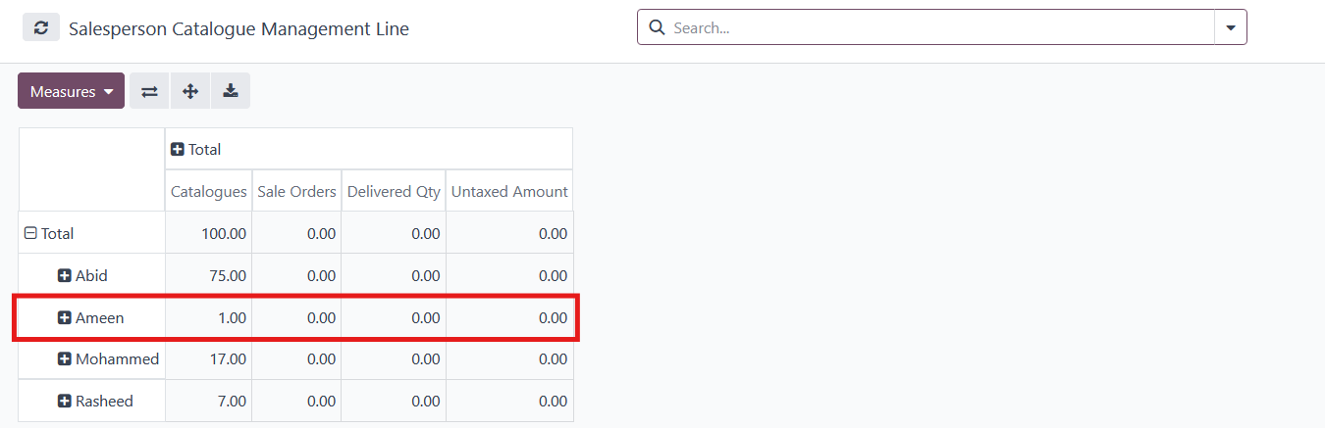

**Salesperson Catalogue Management**